Experiment 1:
Ohm's Law and discharging of a capacitor
Background:

Capacitors store electrical charge according to the equation
(1)
where C is capacitance, Q is charge, and V is voltage.

When a capacitor is discharged, is is possible to prove that the voltage will decrease as a function of time according to the equation
(2)
Where V(t) is the voltage at any given time, V₀ is the initial voltage, t is time, R is resistance, and C is capacitance.

In this experiment, the resistance of a resistor will be calculated using Ohm's Law. A charged capacitor will be discharged, and the capacitance of the capacitor will be calculated using linearization of data techniques.

Materials you will need:
A Multimeter (or SPARK with Current and Voltage sensor)
One Resistor
One Capacitor
Alligator-Clip Wires
Power Supply

Warnings:
DO NOT ADJUST THE POWER SUPPLY ABOVE 5V – It will burn out the LED
USE ONLY THE DC SIDE OF THE POWER SUPPLY WITH BLACK AND RED TERMINAL
Have your instructor check your connections before applying power to the circuit.

Procedure:
Connect the circuit in the following configuration:
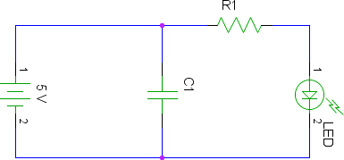

Have your instructor check your connections.
Connect a multimeter or SPARK to monitor the Voltage of the capacitor.
Disconnect the power supply, and monitor the time it takes for the voltage to reach 2.5 V.
Calculate the Resistance of the resistor.

